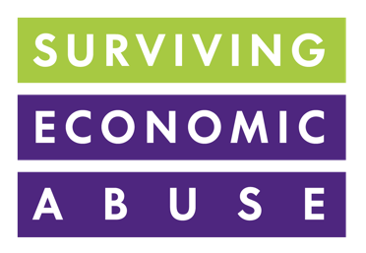
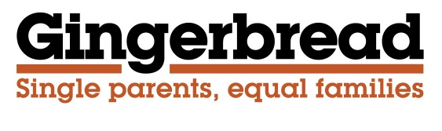

Report Stage Briefing
on the Child Support Collection (Domestic Abuse) Bill
March 2023

Background
We welcome the Child Support Collection (Domestic Abuse) Bill introduced by Sally-Ann Hart MP, which would mean the use of direct pay would be refused where one parent objects to it on the grounds of domestic abuse and where evidence can be provided of domestic abuse. We're also pleased to see that a key outcome of Samantha Callan's Independent Review of the Child Maintenance Service (CMS) response to domestic abuse is the Government's support for the Bill. This change should help stop the withholding of child maintenance or making payments unreliably being used as a tool for coercive control, by an abusive ex-partner.

However, we believe that further changes are needed to the way the CMS operates to ensure that the system works more effectively for domestic abuse survivors and that amendments to this Bill provide an opportunity to make those changes. In particular, we are concerned that no changes are proposed around the charges for using Collect and Pay and there are no proposals for minimum payments to be paid to victim-survivors of domestic abuse, while enforcement is pursued.

We also have significant concerns that there is a lack of understanding within the CMS about the dynamics of domestic abuse to make sure that decisions about moving someone across to Collect and Pay are made correctly. The evidence that will be needed to prove incidences of domestic abuse clearly needs careful consideration. Ensuring adequate training of staff and the development of domestic abuse expertise within the CMS is also essential.

Collection charges
For those using “Collect and Pay”, where the CMS collects and passes on payments, the Non-Resident Parent must pay an extra 20% of the maintenance due and the Parent with Care receives 96% of the child maintenance allowance paid by the Non-Resident Parent. These charges clearly indicate that the current system is designed to penalise those who go on to Collect and Pay, suggesting that it is in some way incompetent or difficult parents who cannot manage their affairs between themselves that get on to this system. While it is accepted that Collect and Pay is more expensive for the state to administer than Direct Pay as it requires more state intervention to operate, receiving parents who are domestic abuse survivors should be exempt from this charge given that for them Direct Pay is either not a realistic option or is a dangerous one.

We believe that domestic abuse survivors should be exempt from the charges seek a clear commitment from the Government to change The Child Support Fees Regulations 2014 to that end

During Second Reading of the Bill, it was heartening to hear DWP Minister Tom Pursglove say that consideration was being given to exempting domestic abuse survivors from collection charges. This was echoed by Minister Mims Davies during Committee Stage.

Minimum payments
Lack of proper enforcement of child maintenance is an endemic problem, and stems from structural imbalances in power between receiving and paying parents. SEA’s The Cost of Covid-19 report found that 84% of women were worried about their access to child maintenance payments as a result of the perpetrator’s actions during the outbreak. 22% of women reported that the perpetrator had stopped paying during the outbreak, 20% said that the perpetrator had paid less, and 18% said that the perpetrator had paid unreliably. It was crucial that there be better support during the pandemic for victim-survivors who were missing out on child maintenance payments to which they were entitled. It is even more crucial during the current cost-of-living crisis.

We repeat the call made in the report that the government must support victim-survivors of economic abuse by making minimum payments to them where the paying parent fails to pay, in order to prevent them from sliding into (further) poverty as a result. These can then be recovered through enforcement action. Amending the Bill to introduce this change would further enhance the Bill's aim to support domestic abuse survivors. We would be delighted to work on drafting an amendment to the Bill that would put this into place.

Understanding of domestic abuse in the CMS
We have significant concerns about the current levels of training and expertise in the CMS on supporting domestic abuse survivors. We would feel more assured that the right steps were being put in place, if we and other organisations with expertise in this area could work with develop with Government statutory guidance on what should be covered by training. We would be delighted to work on drafting an amendment to the Bill to provide for the development of statutory guidance on training.

Summary
We support the principles of this Bill to improve the system for collecting payments through the CMS for domestic abuse survivors. However, we believe that without the following amendments, the Bill will not achieve its objectives:
- A requirement for statutory guidance to set out the training that staff within the CMS will receive on domestic abuse, including economic abuse. We would be happy to draft an amendment to put this in place.
- Receiving parents who are domestic abuse survivors should be exempt from the Collect and Pay charges. A probing amendment could help to secure agreement from the Government to change regulations to make this happen.
- DWP to introduce a system of making minimum payments to the receiving parent, when the paying parent fails to pay. We would be delighted to work on drafting an amendment to the Bill that would put this into place.

Please contact Sarah Lambert sarah.lambert@gingerbread.org.uk or Cyrene Siriwardhana Cyrene.Siriwardhana@survivingeconomicabuse.org for more information.

The statutory child maintenance scheme has two forms of payment: Collect and Pay and Direct Pay. Collect and Pay is a legally binding arrangement, where the CMS calculates the amount of maintenance, collects it from the paying parent and pays it to the receiving parent. Direct Pay is where the CMS calculates the amount to be paid and parents make their own arrangements for payments. No further use of the CMS is used after the calculations are made. There are ongoing charges to both parents with the Collect and Pay arrangement, but not for Direct Pay.

