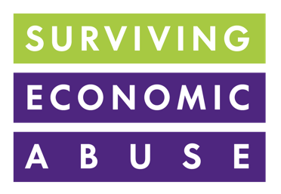
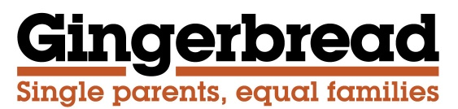

Committee Stage Briefing
on the Child Support (Enforcement) Bill
March 2023

Background
We welcome the Child Support (Enforcement) Bill introduced by Siobhan Baillie MP, which would mean giving powers to the DWP to make certain liability orders without having to apply to the courts and providing the Child Maintenance Service (CMS) with greater ‘teeth’ to pursue non-resident parents who are failing to pay.

In cases of non-compliance, the Child Maintenance Service (CMS) already has the powers to deduct money, including any arrears where appropriate, directly from a non-resident parent’s earnings or to take deductions from bank accounts. However, where non-compliance has been persistent and more serious actions are needed, such as removing a driver’s licence or seizing a passport, the CMS has to apply to the courts. The Bill removes that requirement.

In addition, we would like the Bill to introduce measures to make sure that the CMS are acting as swiftly and as proactively as possible on existing enforcement measures that are available to them. More widely, we would like to see a system where the Government makes minimum payments to parents with care where the paying parent refuses to pay, which they can then recover through enforcement.

Enforcement challenges
At Gingerbread and SEA, we regularly hear cases through our helplines where the CMS is failing to use the enforcement options available to it or failing to follow up on enforcement action that they have taken. This has included unexplained delays for not using a bank deductions order or refusing to use this option as an enforcement measure. We also see the CMS failing to follow up with employers who weren’t complying with deduction from earnings orders (DEOs) or with banks not complying with a deduction order. We further hear of cases where the parent with care believes that the non-resident parent is hiding their true earnings to reduce liabilities. Yet the CMS does little to investigate in many of these cases.

Domestic abuse survivors regularly tell both of our organisations that they don’t feel this is understood or taken seriously by the CMS and that non-resident parents are using the CMS to continue their abuse through economic control by continuing to challenge and question payments to manipulate the system and ensure delays or non-payment. The CMS does not appear to be taking clear action in these cases to ensure payment is made and that parents with care are being paid consistently. Via the recommendations of the recently published independent review of the CMS, Government is taking some welcome action on domestic abuse and the CMS, including looking at the training for CMS staff and supporting the Child Support Collection (Domestic Abuse) Bill, which will mean that in cases of domestic abuse, the domestic abuse survivor can request payments are switched from Direct Pay to Collect and Pay. However, further action is clearly needed to ensure that perpetrators of domestic abuse are not allowed to use the CMS as a means to continue their abuse. More widely, the sheer level of arrears in child maintenance payments – currently standing at around £500million since the CMS was established in 2012 - demonstrates the failures of the CMS in enforcing payments. To improve parliamentary accountability and scrutiny of the CMS, we would like to see the Bill amended to put a duty on the Secretary of State to produce an annual report to Parliament on how the CMS is enforcing payments through actions it is taking to improve enforcement.

Minimum payments
Lack of proper enforcement of child maintenance is an endemic problem. Yet research shows that if child maintenance was paid in full to all children in separated families living in poverty who currently do not receive financial support from their other parent, it would have the potential to lift 60% of them out of poverty.

During the current cost of living crisis, recovering arrears is more important than ever. Ensuring that parents with care receive support while enforcement is pursued is crucial to prevent single parent families falling (further) into debt and experiencing significant financial hardship. That’s why we believe the Government should develop a system of making minimum payments to parents with care and at the very least to parents with care who are victim-survivors of domestic, including economic abuse. These can then be recovered through enforcement action. We would like to see the Bill amended to secure a system of minimum payments.

Summary
We support the principles of this Bill to improve the ability of the CMS to pursue non payment from non-resident parents.

However, the CMS needs further revision to support parents with care in getting the payments they are entitled to. This includes greater use by the CMS of existing enforcement mechanisms available to them and for the Government to introduce a system of minimum payments for the parent with care, to prevent further financial hardship, while enforcement is pursued.

Please contact Sarah Lambert sarah.lambert@gingerbread.org.uk or Cyrene Siriwardhana Cyrene.Siriwardhana@survivingeconomicabuse.org for more information.

The statutory child maintenance scheme has two forms of payment: Collect and Pay and Direct Pay. Collect and Pay is a legally binding arrangement, where the CMS calculates the amount of maintenance, collects it from the paying parent and pays it to the receiving parent. Direct Pay is where the CMS calculates the amount to be paid and parents make their own arrangements for payments. No further use of the CMS is used after the calculations are made. There are ongoing charges to both parents with the Collect and Pay arrangement, but not for Direct Pay.
Hakovirta et al (2019) Child Poverty, Child Maintenance and Interactions with Social Assistance Benefits among Lone Parent Families : A Comparative Analysis. Journal of Social Policy. pp. 19-39

